# Yama Principle 4- Brahmacharya

**What is Brahmacharya?**

* Brahmacharya means control of the senses.
* Brahmacharya also means conduct that leads to the realization of the Self, or Brahman, study of the Vedas and Scriptures, and full understanding of Brahman (ultimate reality).
* Brahmacharya means practicing conduct that leads one to God.

**How can someone practice Brahmacharya?**

* Practice divine conduct
* Practice control of senses
* Remain faithful in marriage
* Seek holy company
* Dress modestly
* Yoga- Practicing the higher limbs requires a tremendous amount of energy or prana. This energy is built up through the practices of yoga such as asanas, pranayama and japa. Meditation helps to develop self control and concentration.

**Who has practiced absolute Brahmacharya?**

There are many famous yogis and spiritual leaders who practiced this principle of yama. For example: Sankara, Jesus, Gandhi, Hanuman, Lakshmana, and Bhishma

From their practice of brahmacharya they had incredible amounts of energy, will-power and thought-power to do great works for the world. Most religions place emphasis on brahmacharya, considering it a higher state of religious practice, and have nuns and monks take vows of purity.

**What are the benefits of Brahmacharya?**

* There are many benefits to health and spiritual life that come from the practice of brahmacharya.
* Practice of Brahmacharya gives good health, inner strength, peace of mind and long life. It energizes the mind and nerves. It helps to conserve physical and mental energy. It augments memory, will -power and brain power.
* Person who practices Brahmacharya will have lustrous (shiny/ brilliant) eyes, a sweet voice and a beautiful complexion. --**Swami Sivananda**

**Additional techniques to practice of Brahmacharya:**

1) Each time you come across someone who offers you gossip or speaks negatively of others, simply decline their offer and tell them you don’t want to hear it, walk away.

2) Remind yourself every morning that you are a human being, a step above an animal, and that you have a responsibility to control your own animal instincts.  
3) Seek out positive tv shows or websites rather than the ones that portray violence or other inappropriate material on the tv or internet.

**Analogy of – Krishna, Arjuna & the Chariot**

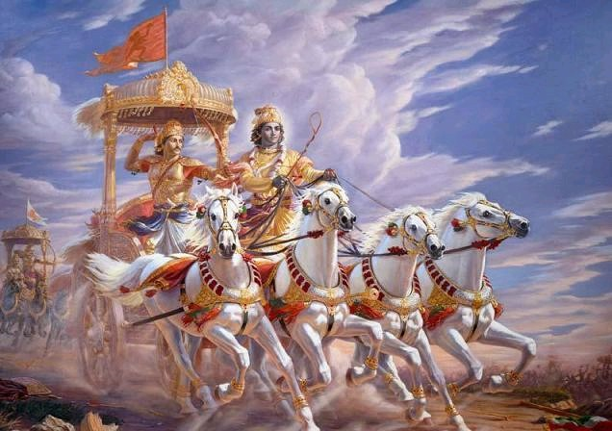

In this picture of Krishna and Arjuna, there is much symbolism in regards to our senses and keeping control of them.

The Chariot – Is likened to the body

The Horses – Are representative of the senses

Arjuna – represents the mind

Krishna (the Charioteer) – signifies the higher intellect or buddhi

It is the nature of horses to follow their animal instincts and run free wherever they like. The mind must be strong in order to give the body and senses orders for direction. However, a strong Intellect / Buddhi can overcome a weak mind and convince the mind towards a righteous path (Through Gayatri Mantra/Yoga/ Meditation/self control).

**Homework:**

1) What does Brahmacharya mean to you? ________________________________________________________________________________________________________________________________________________________________________________________________________________________________________________________________________________________________________________________

2) Do you think that letting the senses lead is a good idea? Why? __________________________________________________________________________________________________________________________________________________________________________________________________________________________________________  
3) List different ways to Practice Brahmacharya. ____________________________________________________________________________________________________________________________________________________________________________________________________________________________________________________________________________________________________________________________________________________________________________________________________________________________________________________________________________________

4) Which one of the senses do you feel is the hardest to control?

__________________________________________________________________________________________________________________________________________________________________________________________________________________________________________

 5) What are the benefits of practicing Brahmacharaya?

______________________________________________________________________________________________________________________________________________________________________________________________________________________________________________________________________________________________________________________________________________________________________________________________________